Quiz2 Oct 3, 2003

First name Last name student id:
First name Last name student id:

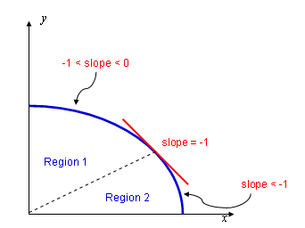

Compute the decision variable for scan converting an ellipse using midpoint algorithm.

Compute the decision variable as an incremental equation.

Write the pseudo code for the midpoint ellipse algorithm.

Tip: there would be two separate loops, for each region.

