Assignment #8
Instructor: Richard Frank (rfrank@sfu.ca)
TA: Ankit Gupta (aga53@sfu.ca)

Total Marks: 50 (5% of the Individual Assignments)
Due Date: Nov 11, 14:30 (via the Online Submission Server)

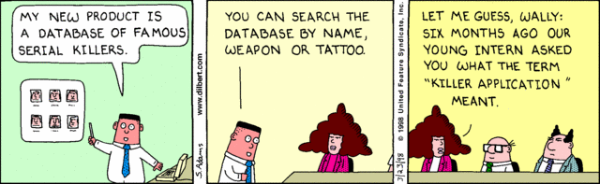

Question 1) You are in charge of testing the Killer Application which Asok (the intern) developed for his Pointy-Haired Boss. You find out it is vulnerable to SQL Injection. Please describe 4 methods you could use to secure the Killer Application against SQL Injection. State what the approach is, how it works, and how it will secure against this attack, or how it will minimize the data-loss should this attack be successful. [10 marks each]

Question 2) [5 marks each]

- Poor Asok (username: Asok) messed up the Killer Application, thus his access to the AdventureWorks.Products table has been revoked. Please write the SQL command to do this.

- To replace Asok, the megalomaniac Dogbert (username: Dogbert) has been given the privilege to manage the Products table as he sees fit (i.e. so that he can give others the privilege to allow others to access the table). Please write the SQL command to do this.

