Installing SQL Server 2008 R2 Express.

Make sure your OS is up to date.
Download from: http://www.microsoft.com/express/database/

Run the EXE file downloaded. It’ll extract a bunch of stuff.
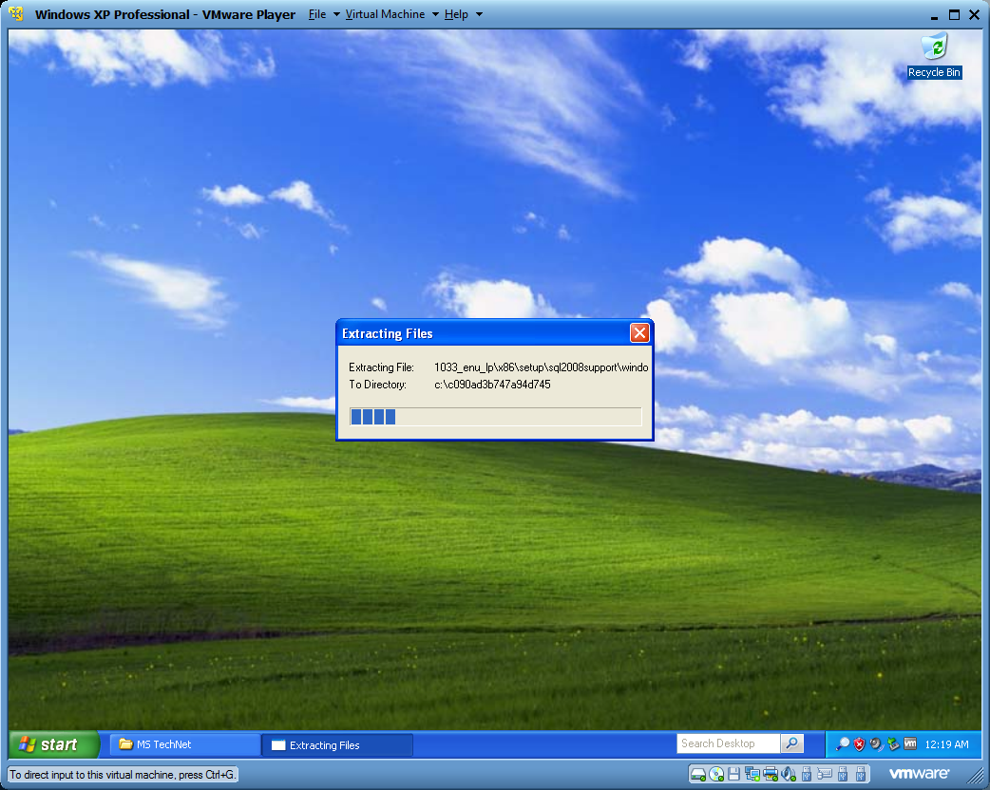

This might happen:
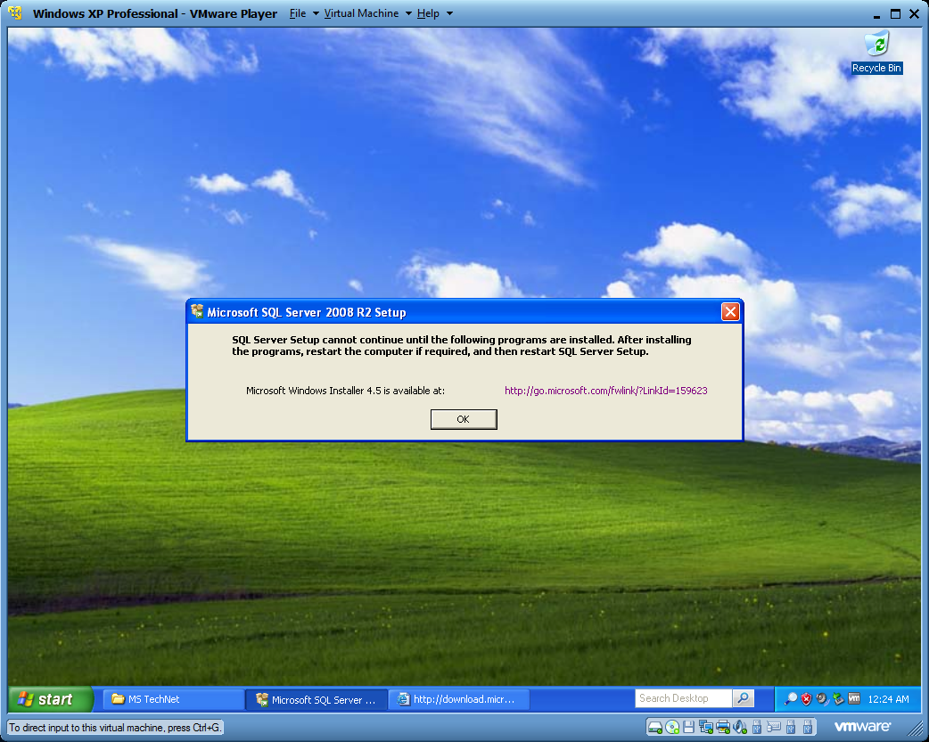
Install it.

After waiting a bunch of time for decompressing…
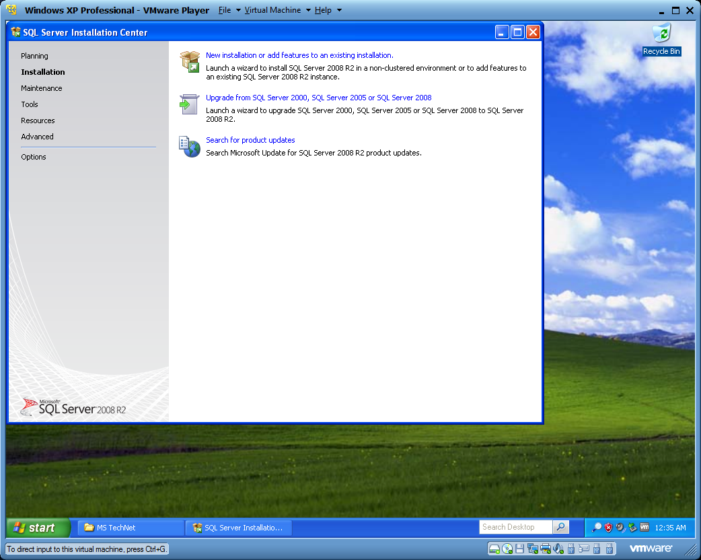

Click ‘New installation…’

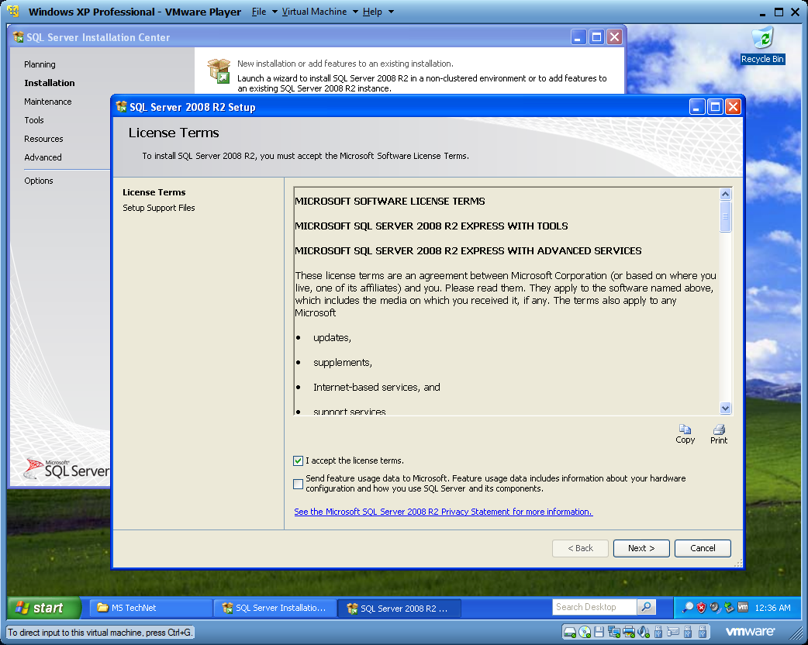

Accept the terms, and click NEXT.

This might happen:
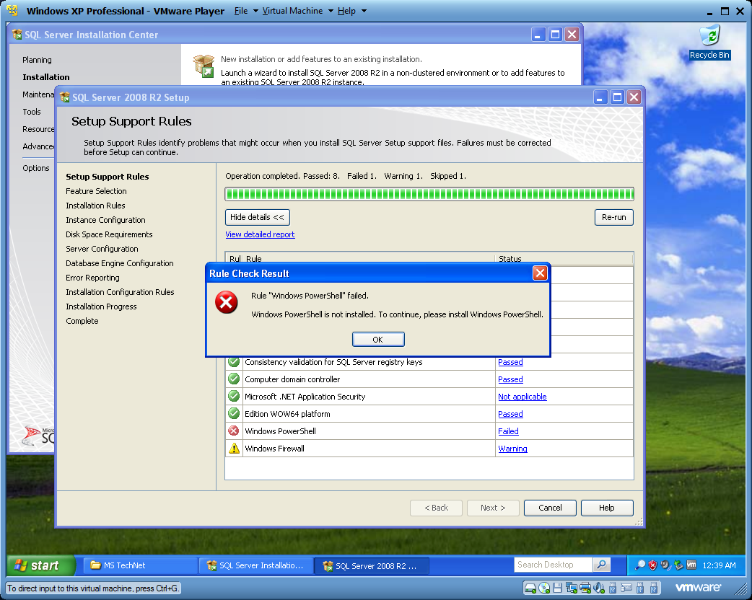
IF you see this message, do this:
- Download update KB968930 [http://www.microsoft.com/downloads/details.aspx?FamilyId=60cb5b6c-6532-45e0-ab0f-a94ae9ababf5&displaylang=en]
- Install.
- Once installed, click ‘Re-run’.

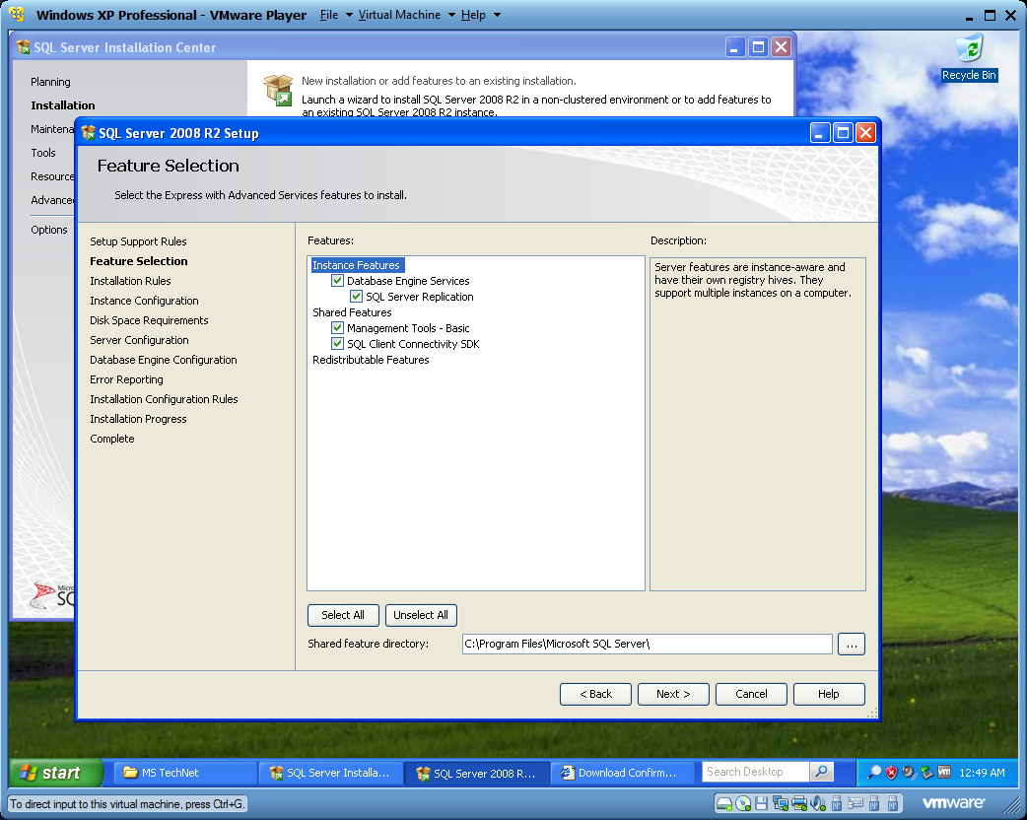
Install everything. Click NEXT.

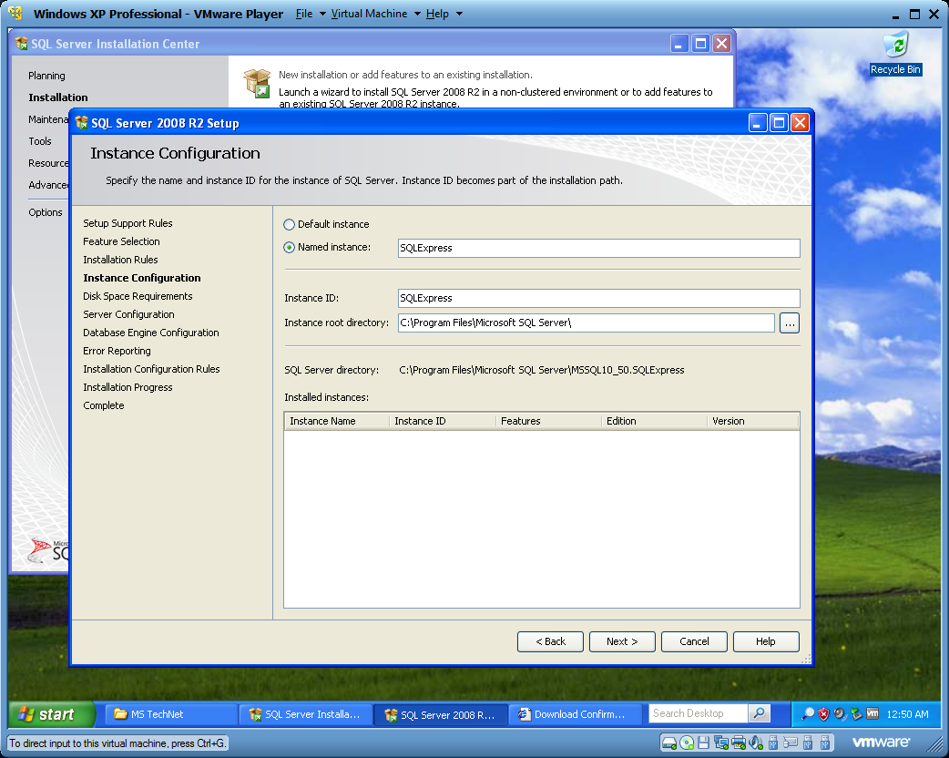
Click NEXT.

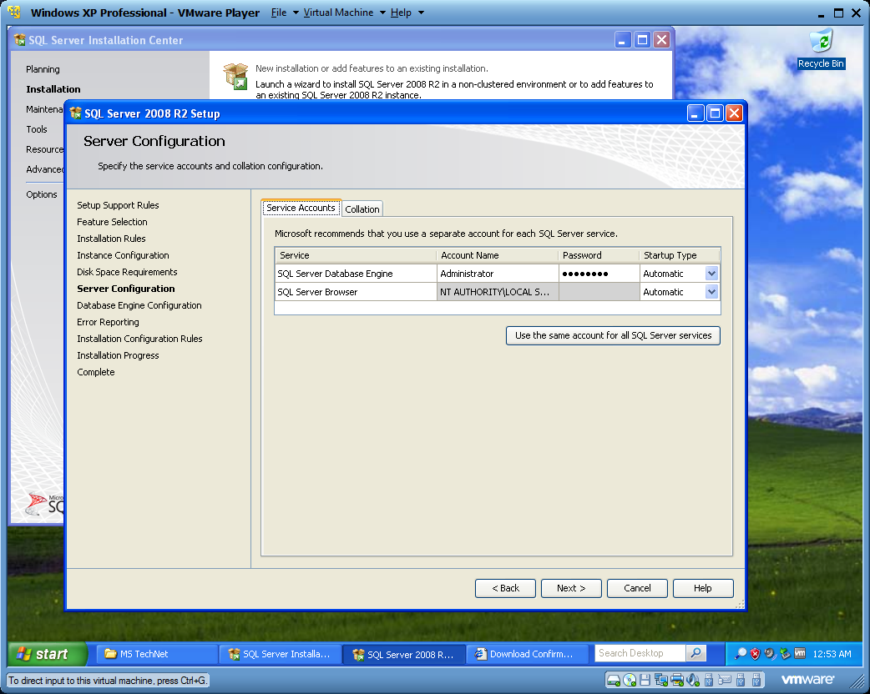
Account name = your logon for Windows.
Password = your password for your Windows account.
Change Startup Type for SQL Server Browser to ‘Automatic’.
Click NEXT.

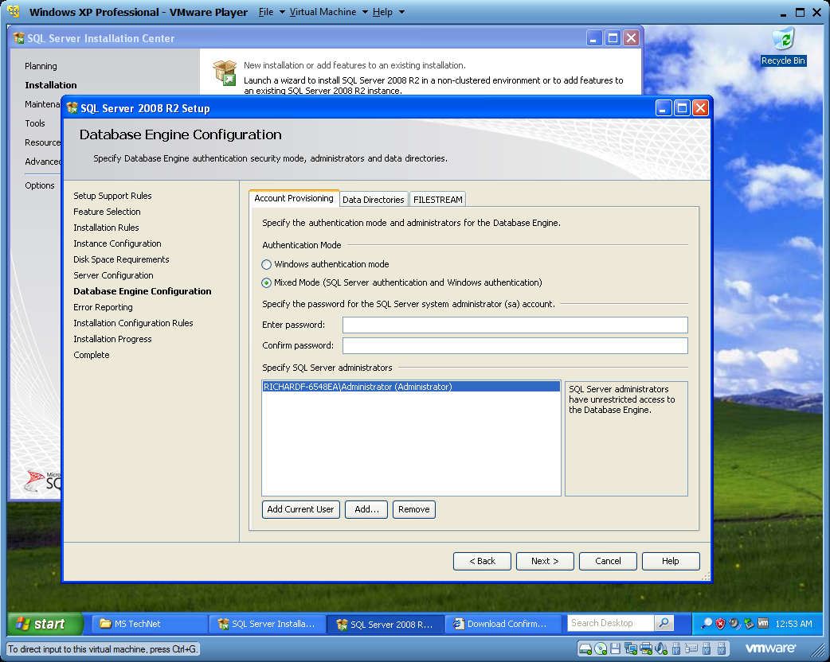
Select ‘Mixed Mode’.
Enter a password of your choosing.
Click NEXT.

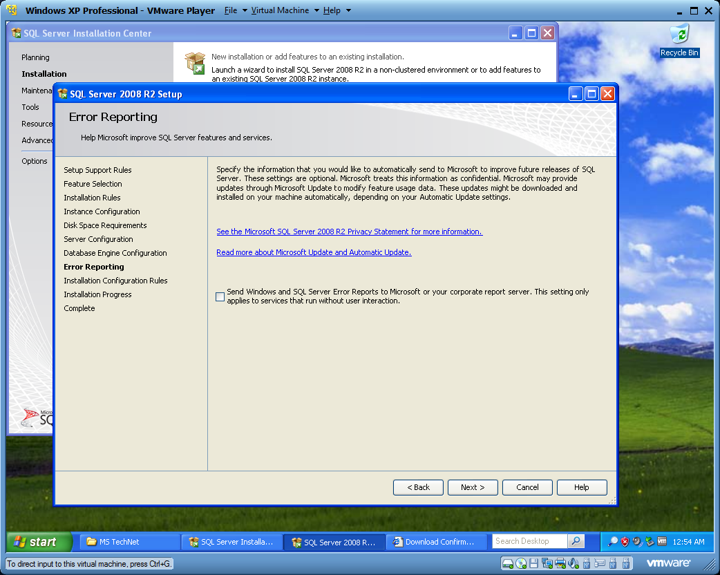
Click NEXT.

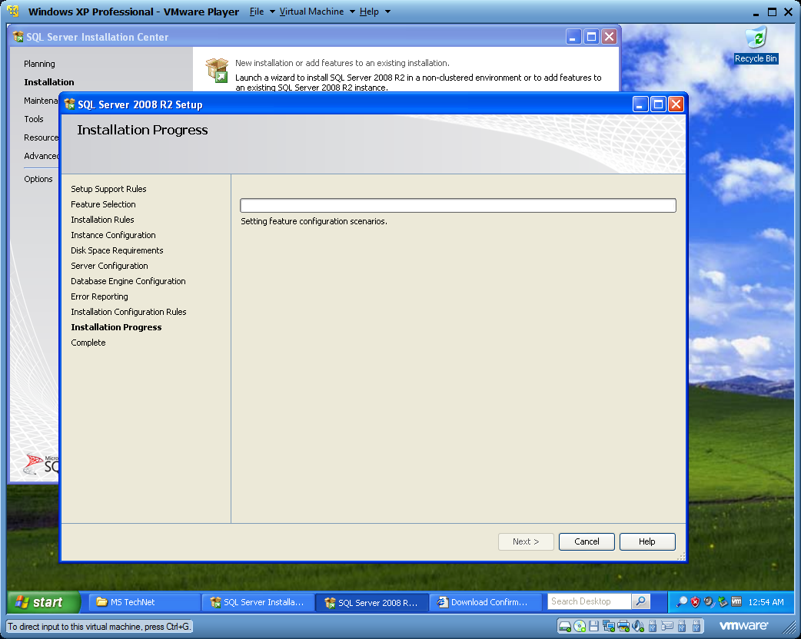
Installation will start.
Go eat something, then wash some dishes.

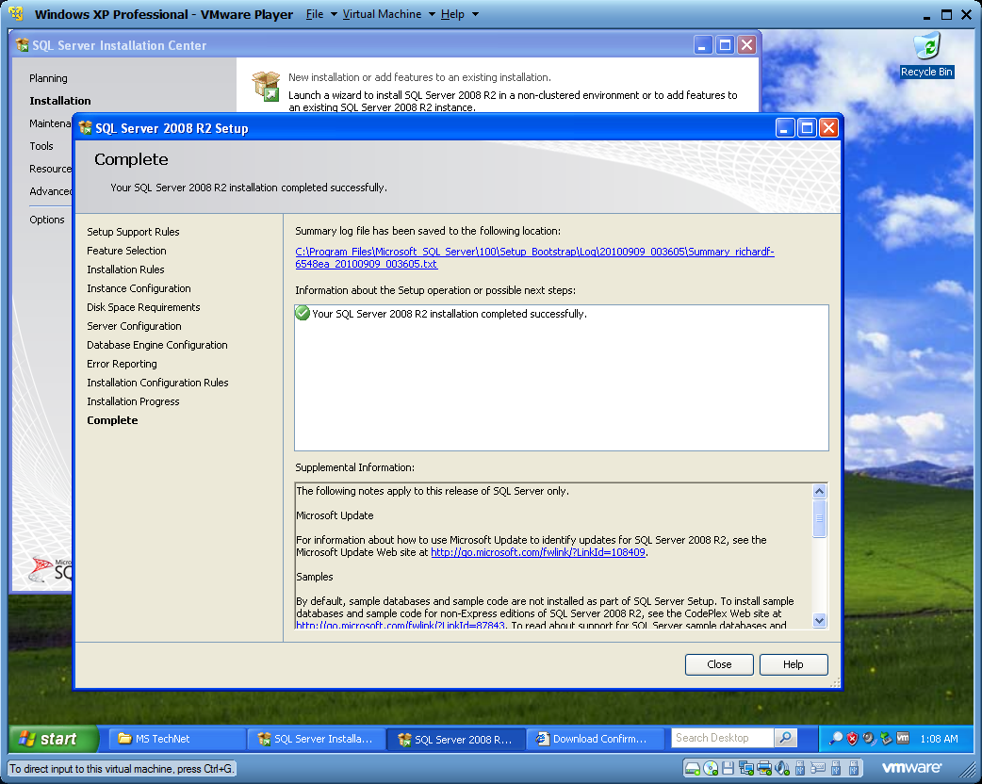
Done!

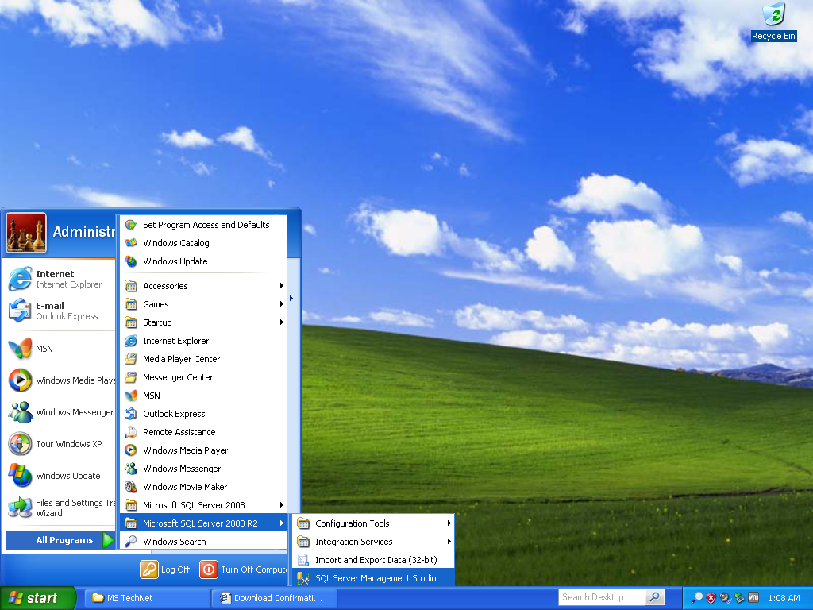
Load up SQL Server Management Studio.

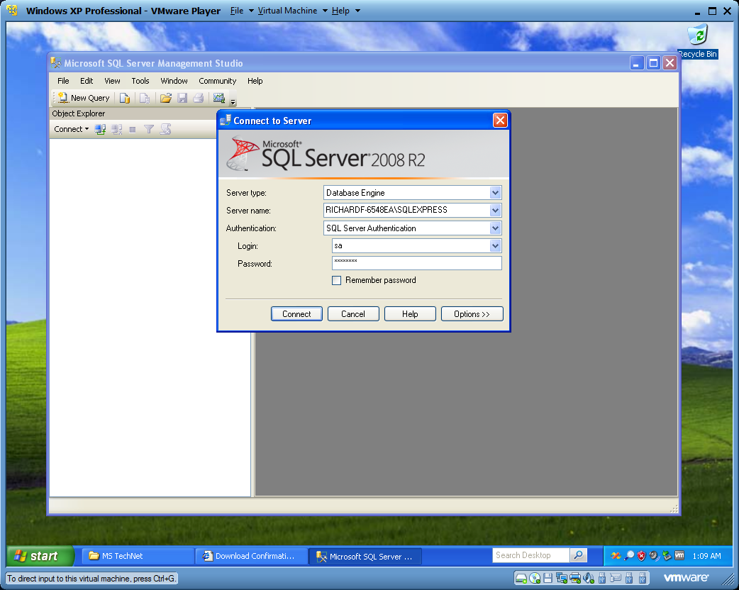
Change Authentication to ‘SQL Server…’
Login is ‘sa’.
Password is the password you specified during setup.

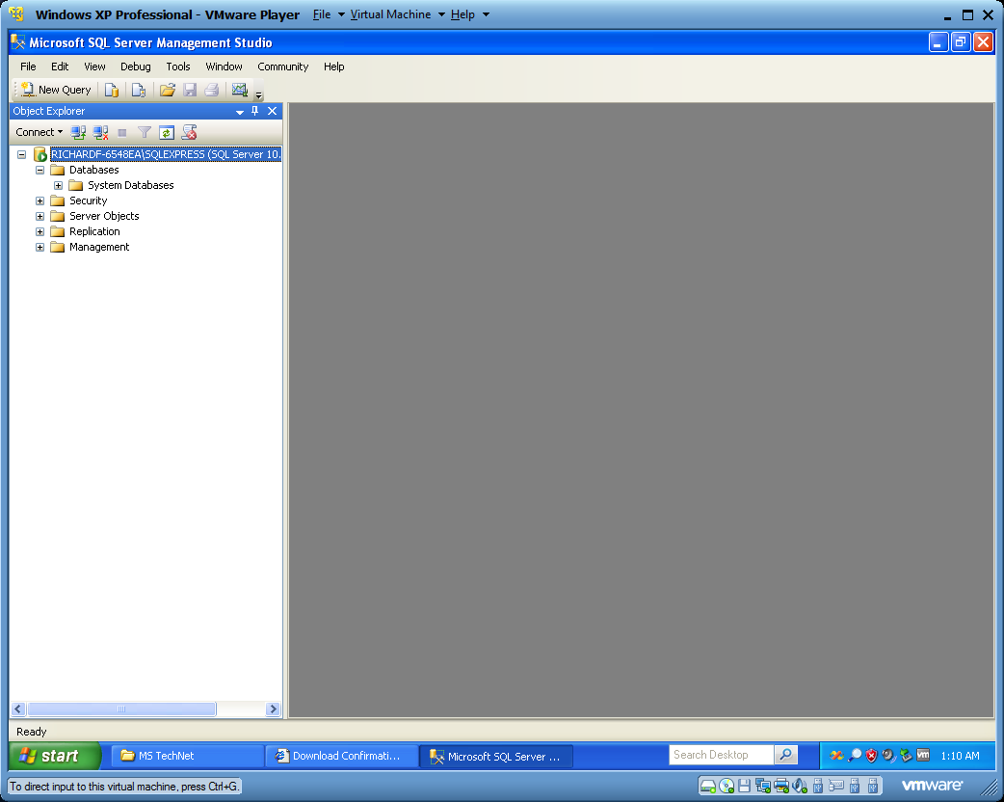
Notice there are no databases installed (attached).

Take the database that was downloaded from the course website.
Uncompress it.
Right click on ‘Databases’ ‘Restore Database’.
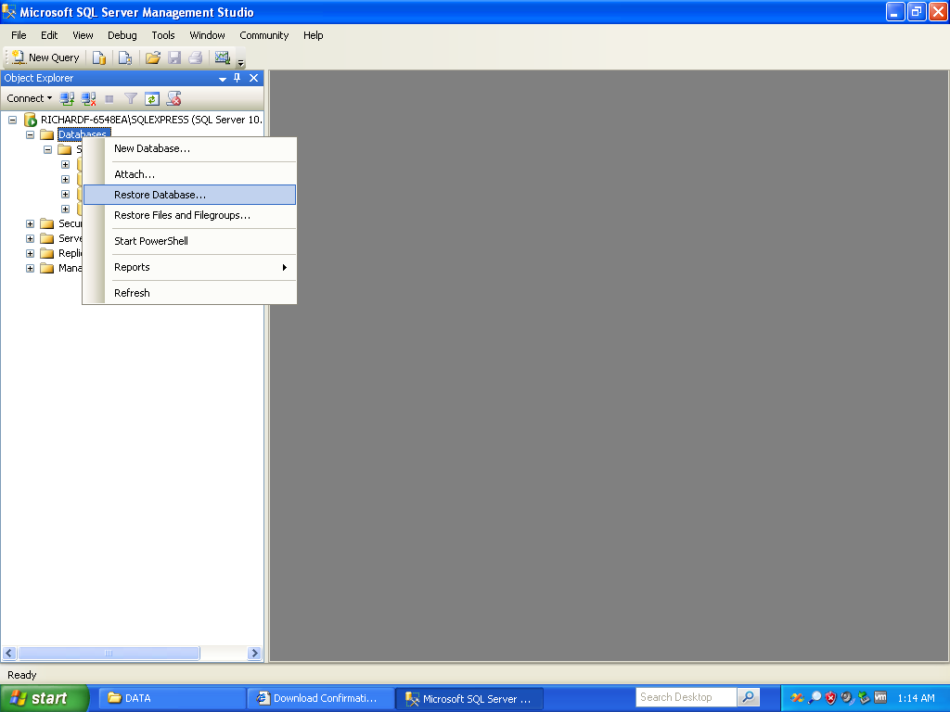

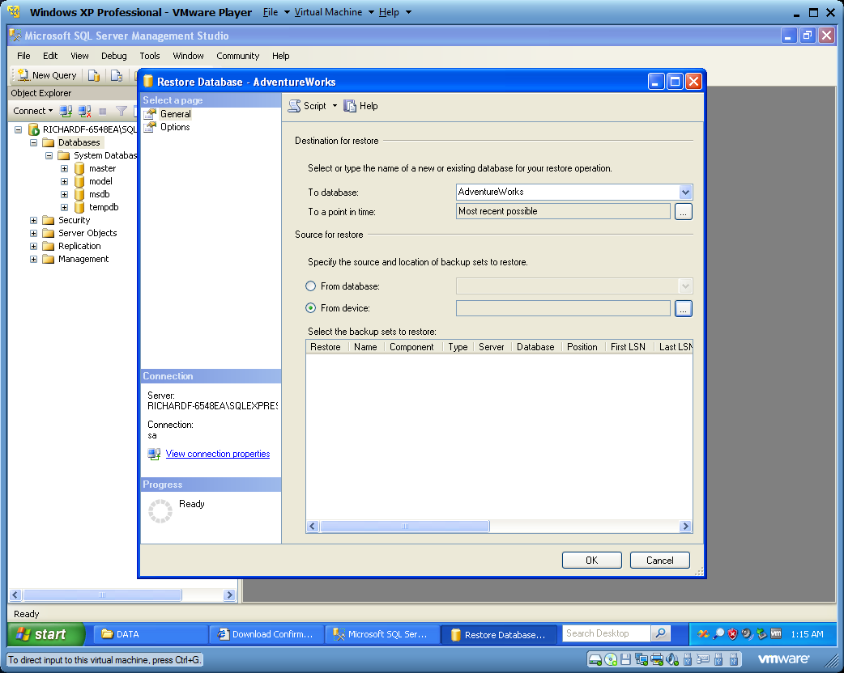
In the ‘To Database’ field, put in ‘AdventureWorks’.
Select ‘From Device’.
Click on ‘…’ beside ‘From Device’.

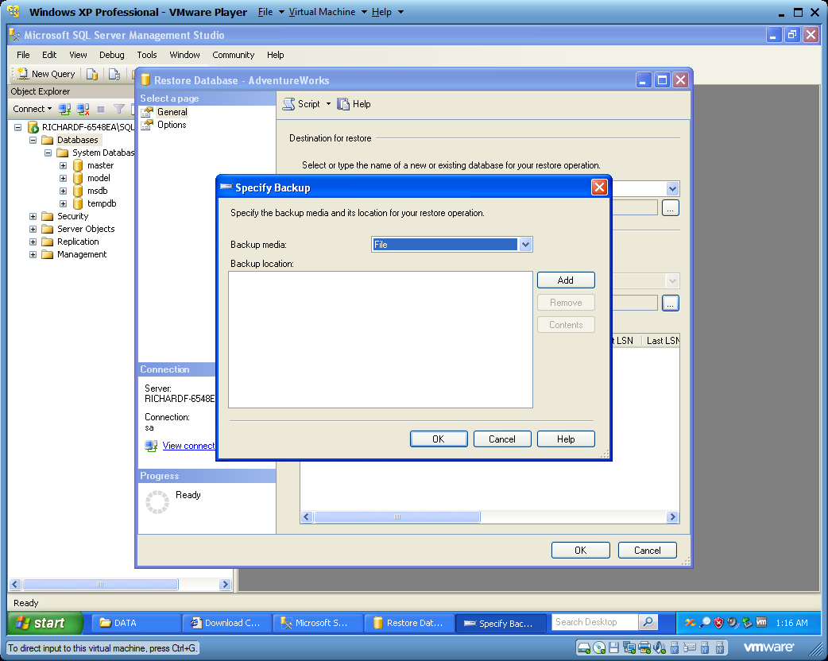
Click ADD.

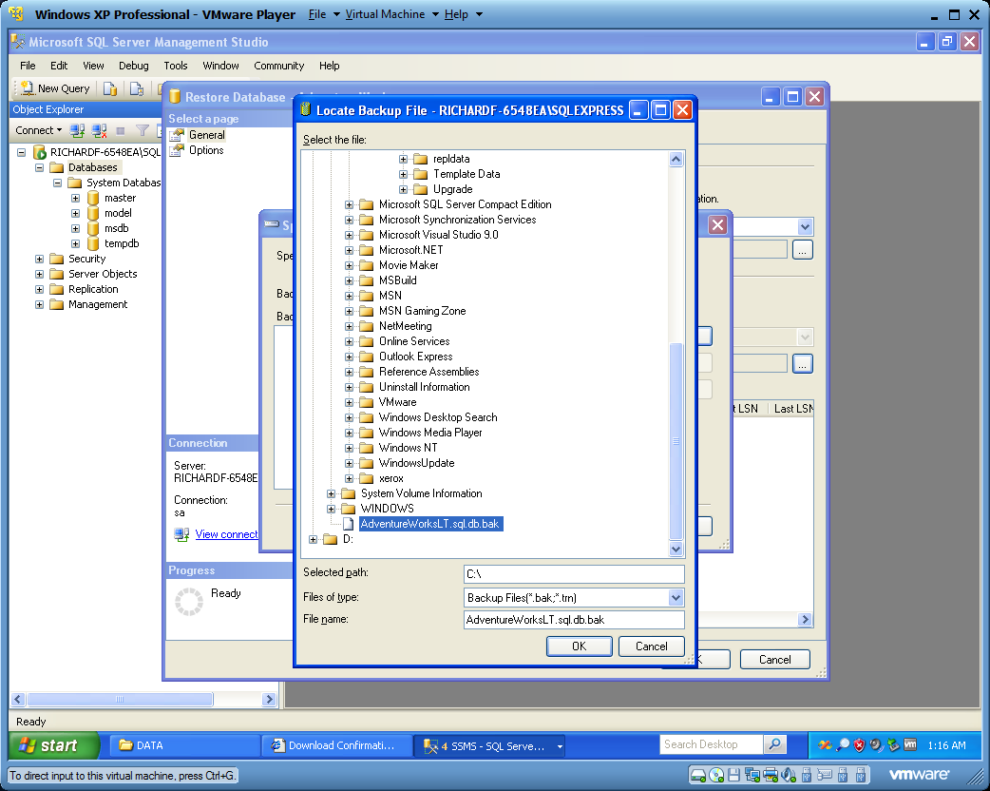
Navigate to where you uncompressed the database you downloaded.
Select it.
Click OK.

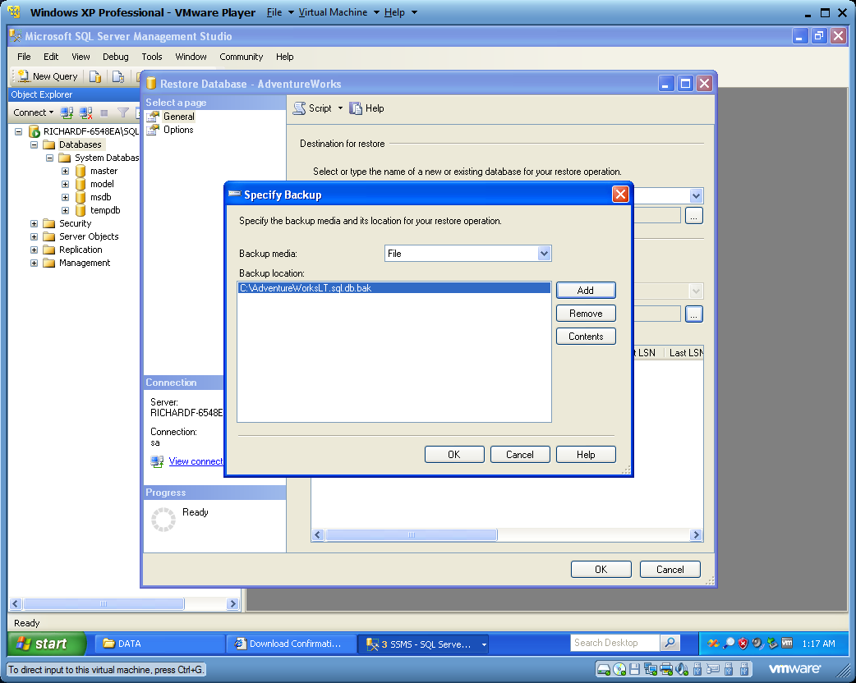
Click OK.

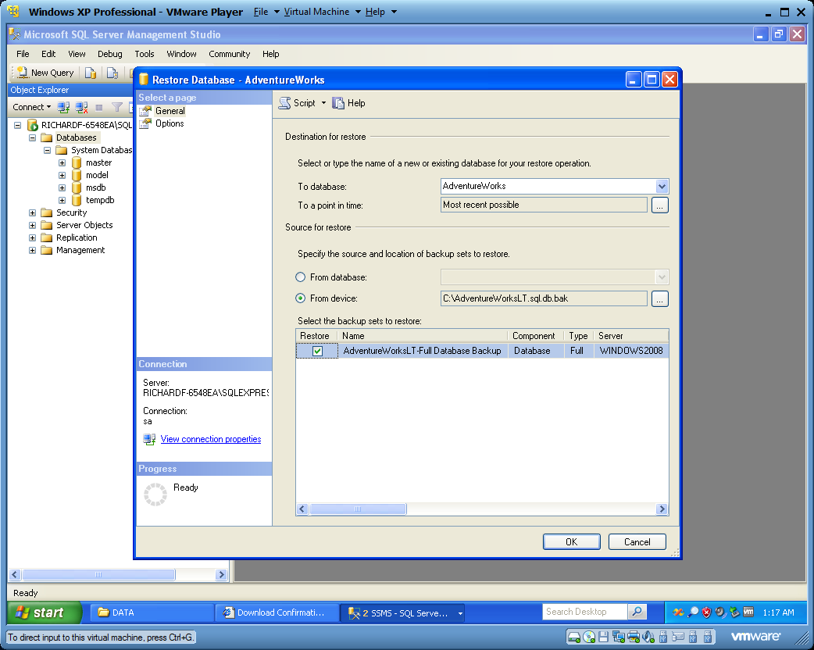
Check off the box in the first row.
Click OK.

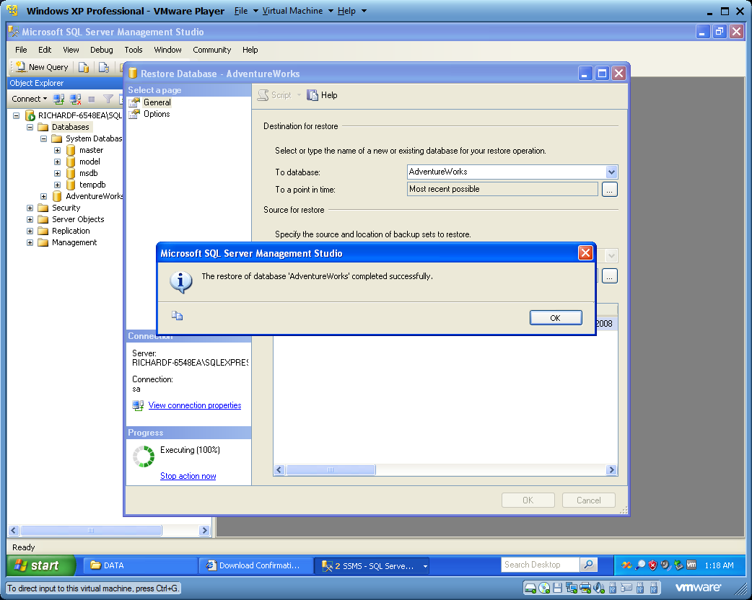
Click OK.

You now should the AdventureWorks database attached to your DBMS.
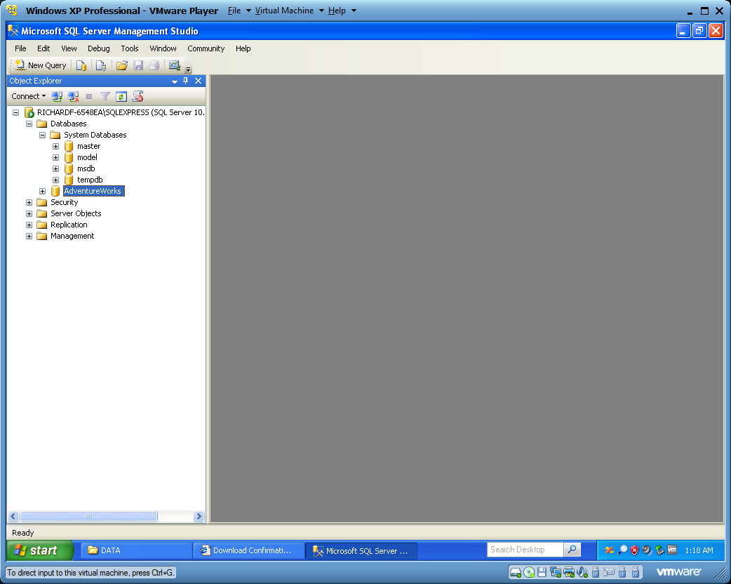

Right click, select ‘New Query’.
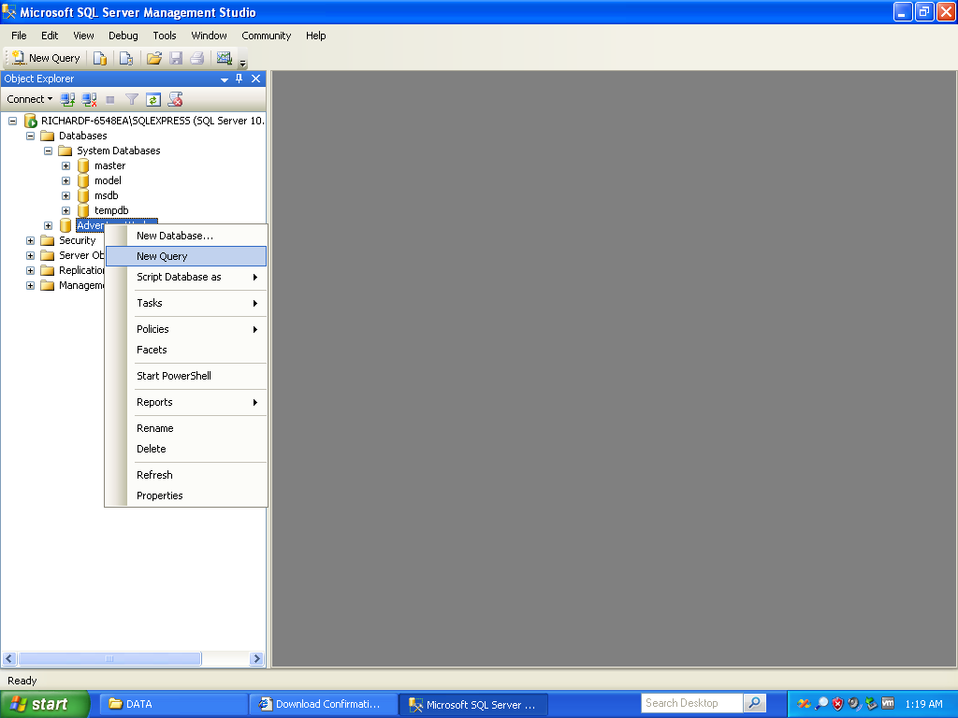

Try a sample query: SELECT * FROM SalesLT.Address
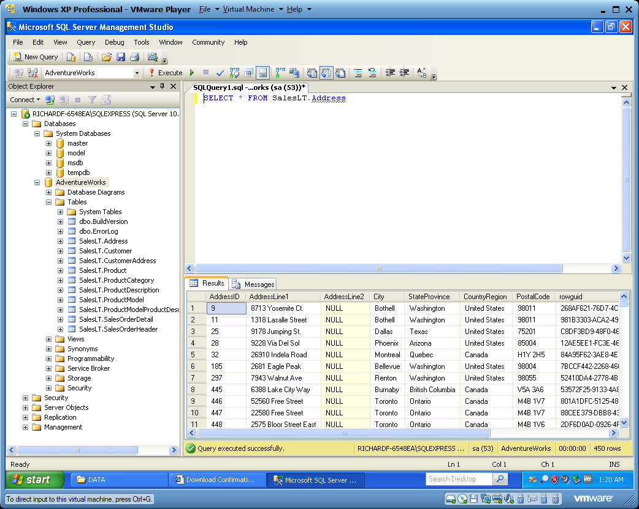

The end.

